Home-School Agreement Policy

Date Published | September 2020
Version | 1
Approved Date | November 2022
Review Cycle | Annual
Review Date | November 2023

An academy within:
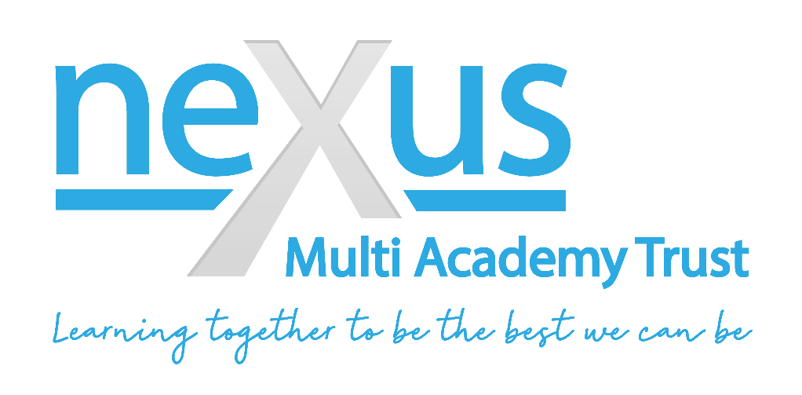

- Principles of the agreement

  - This home-school agreement policy has been updated October 2021 to take in to account COVID-19 guidance.

- What pupils and families can expect from us

- A hygienic environment that is compliant with all the latest COVID-19 guidance;
- A positive leaning environment with opportunities for success;
- An individual education plan with a personalised curriculum;
- A safe, caring and supportive environment where staff are trained to keep you safe;
- To be treated in a respectful manner at all times;
- Opportunities for personal and social development;
- Regular feedback about progress and participation to your parents/carers;
- To share information with other agencies you are working with.

- What we expect from pupils

  - To protect yourself and others from the spreading or catching COVID-19:

- To wash your hands before you leave the house and when you come in to the school buildings;
- To follow social distancing rules and the school’s risk assessment(s);
- To use and touch your equipment only and to wipe down your workspace;
- To use a tissue or sneeze/cough in to your elbow if you need to when at school.

  - To get the most out of your time at school:

- Attend and be on time
- Aim to make good progress and fulfil your personal targets
- Dress appropriately
- Respect property and the environment
- Use of appropriate language to staff and pupils. Be kind to others.
- Remain on the premises unless otherwise authorised by staff or parents
- Let us know if you need help or feel you are struggling

  - To keep a focussed and safe learning environment. Pupils are not allowed:

- Mobile phones or electronic devices to be used during lesson times;
- To smoke on premises, during offsite activities or while travelling to offsite venues.

- What we expect from parents/carers

  - To protect yourself and others from the spreading or catching COVID-19:

- Do not send your child to school if they are displaying any of the symptoms related to COVID-19 (Dry persistent cough, temperature, loss of smell or taste etc.). This is not a full list of symptoms. If you have any queries please refer to government and NHS guidance;
- Ensure your child washes their hand for 20 seconds with soap before leaving the house and travelling to school;
- Supply your child with water in a water bottle for your child to drink during lessons. We are not allowed to provide drinks at this time;
- Ensure government guidelines with respect to isolation are followed in your household;
- Ensure students have a COVID-19 test if they have symptoms, parents to inform school of outcome at earliest opportunity;
- Ensure pupils bring the minimum number of items to school;
- To ensure you child has the best experience and to keep them safe;
- Ensure your child has had their medication at the appropriate time and that school have a supply of any relevant medication e.g. EpiPen, inhalers etc. Please ask your learning mentor for more details.
- Arrange for your child to be at school on time;
- Inform the teachers and school of any new diagnoses, medical or other conditions which may affect learning, e.g. hearing, dyslexia;
- Provide the maximum notice possible by phone if it is absolutely essential to cancel a lesson;
- Attend review meetings and CAMHS appointments as appropriate.

- Attendance

  - The school works within the parameters of the Nexus MAT attendance policy.

  - At present we are reporting attendance as required to the DfE, Local Authorities and home schools (where a child is dual rolled).

  - If a child has not been able to attend a planned session we will follow this up in several ways:

- Immediate phone call if it is thought there may be an immediate risk of harm to the pupil;
- Phone call or text to parents/carers to find out if everything is ok and to monitor pupil progress and well-being;
- Email or phone call to the pupil by Form Teacher or Learning Mentor dependent on your child’s individual circumstances and what is most appropriate;
- It is important for your child’s welfare that reasons for non-attendance are reviewed in this way so that we can work out with you the best way to support you and your child to access education.

